PfSense & SEIM WAZUH Deployment Lab
PfSense Deployment

Downloading and installing:-
Download the official image file of Pfsense firewall from netgate website after creating account . After that download the file.

After you are done downloading, you can install the Pfsense firewall using Virtual Box or Vmware Workstation, during installation please make sure you have steady internet connection. When installation is done, you will see interface like this
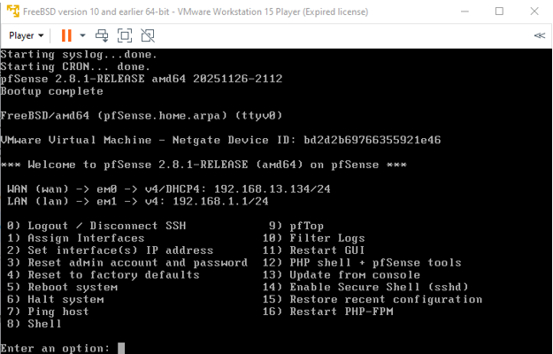

Connecting pfsense with Kali linux
To connect your Linux(Kali Linux in my case) to pfSense, first set network adapter 1 to NAT on pfSense, and adapter 2 to a custom LAN SEGMENT that I named pfsense to connect other devices to pfSense.
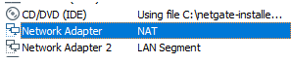

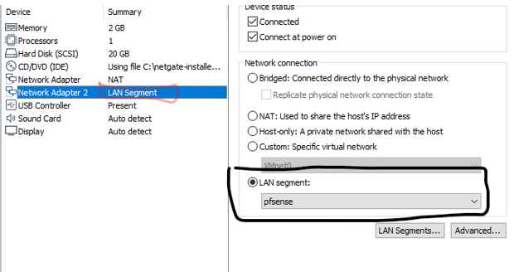
Now in Kali Linux VM, select LAN Segment ‘pfsense’ to connect pfsense with Kali Linux as shown below.
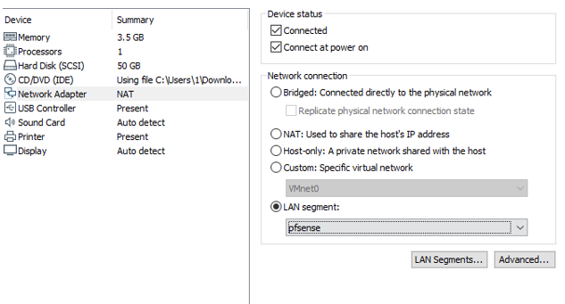
PFsense configuration through GUI
You will see GUI like below when you type LAN IP that you saw on interface when installation was done. Login with default credentials and then change password for better security.
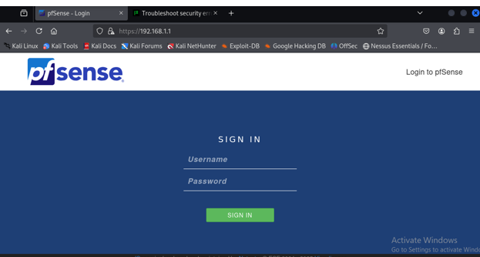

DHCP configuration
navigating to Services > DHCP Server in the web interface and selecting the specific interface tab (e.g., LAN) you want to configure. You will see section when you come to DHCP server settings.
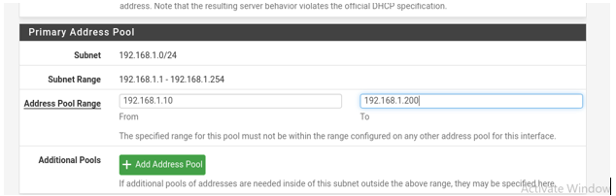
Verify on client linux VM if you are getting IP assigned by Pfsense DHCP server according to your configured IP pool
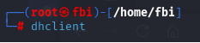
Type dhclient dynamically obtain or renew an IP address, subnet mask, default gateway, and DNS server information from a DHCP server of the PfSense firewall.
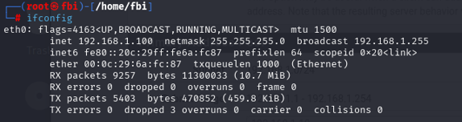

CREATING FIREWALL RULES: Blocking a website using pfSense GUI
By default, it allows all LAN traffic and blocks all WAN traffic.

Go to firewall->aliases-> to add URL of facebook. Select type as ‘Host’ and enter alias and URL of facebook like www.facebook.com

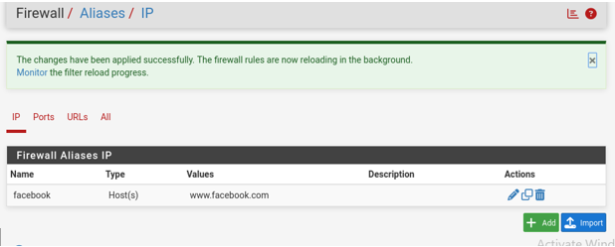

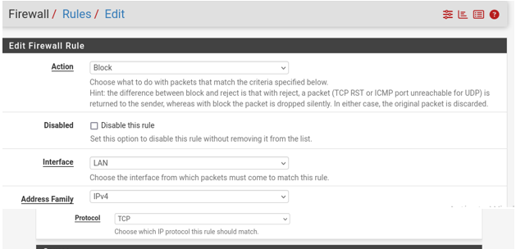

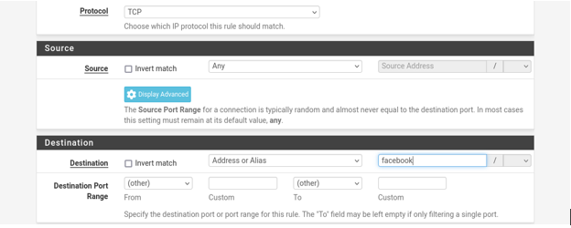
Save the settings and now rule to block facebook is added

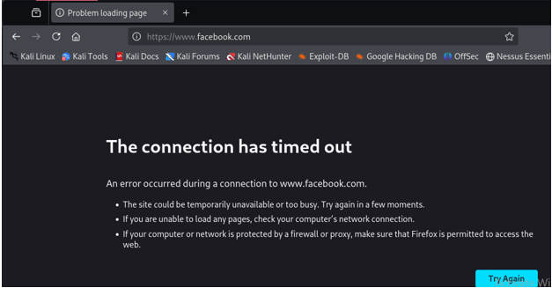
Facebook is blocked
CREATING FIREWALL RULES: Block ICMP (Ping) to the Internet
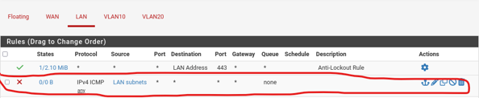
Now I cannot ping because I added rule to block ICMP.
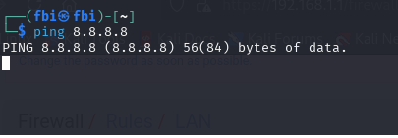

Creating VLANs and Inter-VLAN Routing
Go to Interfaces->Assignments->VLANS to create VLANs

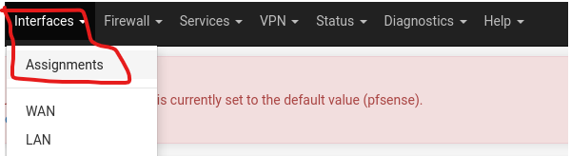

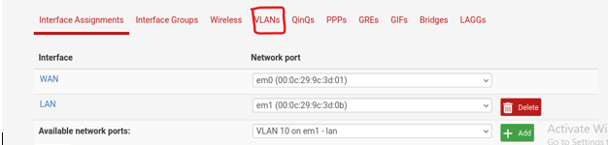
To assign IP Addresses to these created VLAN 10 and 20 go to Interfaces → Assignments → Add Interfaces:
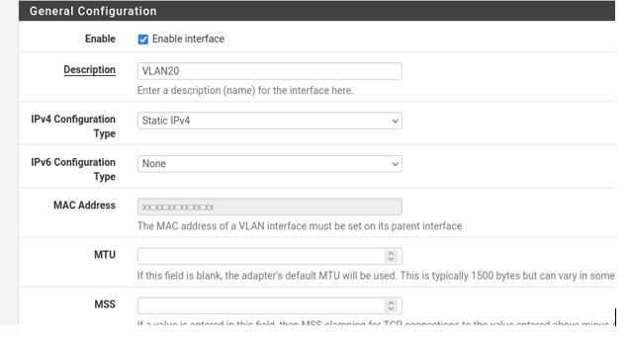
Don’t forget to check Enable interface checkbox to turn on the interface
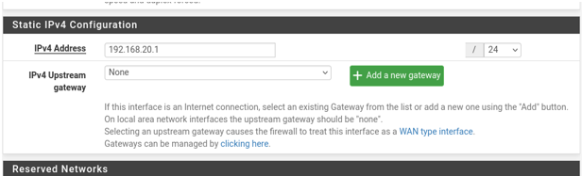

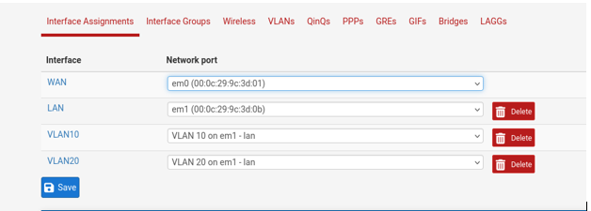

Don’t forget to save at the end. Now enable DHCP for both VLANs by going to Services → DHCP Server →VLAN10
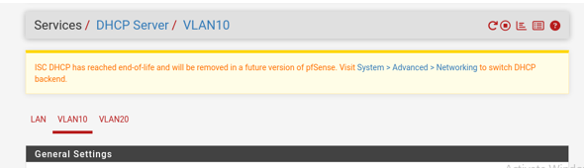

Check enable DHCP server on VLAN10 & VLAN20 on both VLANs and add IP ranges on both VLANs. 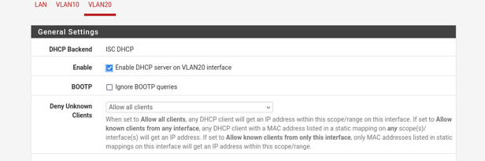
Now DHCP for VLANs and inter-VLAN routing is enabled.
Blocking VLANS from accessing other VLANs
Go to Firewall->Rules->Vlan10(the name of VLAN will be what you named it in VLAN settings)
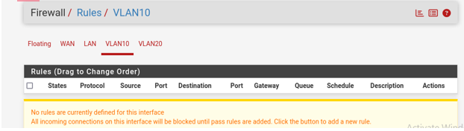
To block VLAN 10 access to VLAN 20, I added these configurations
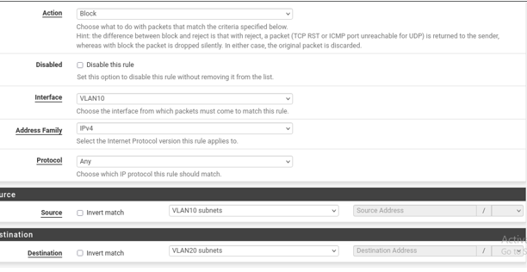
And save settings
Now test the pings to see if Access to vlan 20 is disabled from vlan 10. Also test to see if access to vlan 10 from vlan 20 is allowed by pinging.
For this to work you need to make 2 custom VMnets for VLAN 10 and VLAN 20 in Vmware virtual network editor like this:
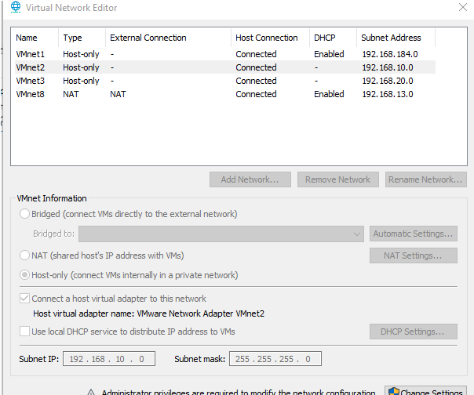
You might need to add your respective VLAN’s IP subnet at the end of the virtual network editor, as I did, and uncheck Use local DHCP service to distribute IP Addresses to VMs.
After that, go to any of the test VMs' network settings and select VMnet 2 and VMnet 3 for VLAN 10 and VLAN 20, or whatever VMnet you selected for your respective VLANs. Like if I want some device or virtual machine to be in VLAN 20, I will go to VM configurations and then network adapter and in custom adapter, I will select the adapter which I configured for the VLAN I want my VM or device to be in. For instance if I want my device to be have IP of VLAN 20’s pool I will go to network adapter settings of that VM and if like VMnet2 is the adapter that is for the VLAN you want your device to be in so select that in custom network adapter like demonstrated below

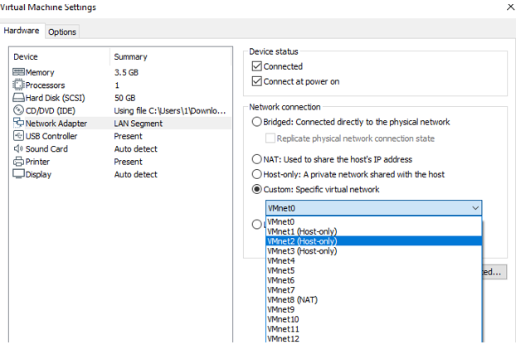

WAZUH DEPLOYMENT
Installing Wazuh on Ubuntu Linux
First Run these Commands to download config file and to download wazuh-install.sh which we need to install indexer, server and dashboard for WAZUH SIEM.
Edit the config.yml file with your IP in indexer, server and dashboard sections. For instance, my IP was 192.168.120.128 so I inserted my IP at designated places. Use nano command to edit config.yml file.
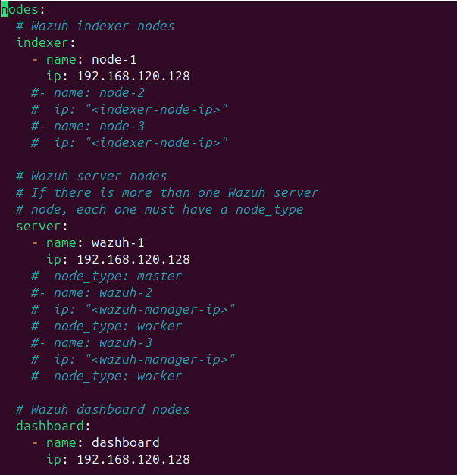

Run sudo bash wazuh-install.sh --generate-config-files command to generate configuration files before installing Wazuh indexer, server and dashboard.
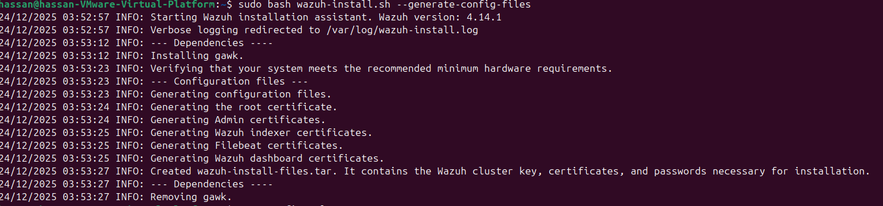

Now, install the wazuh components using sudo bash ./wazuh-install.sh –a where –a means that we are instructing to install all components of Wazuh like indexer, server and dashboard.
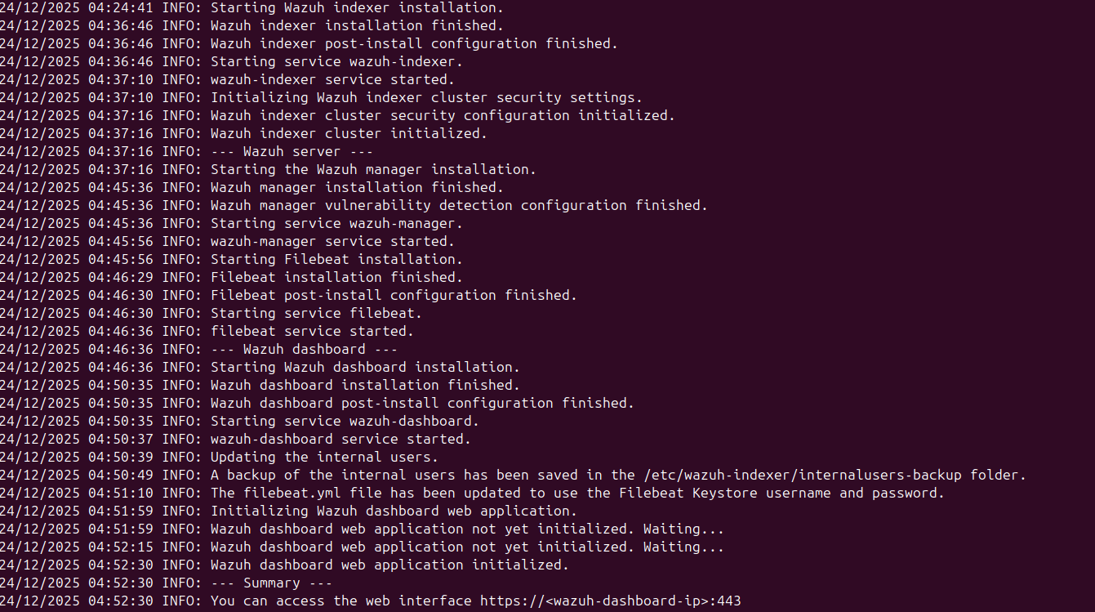

Now I type your IP in browser that you wrote in config.yml file to access Wazuh SIEM.
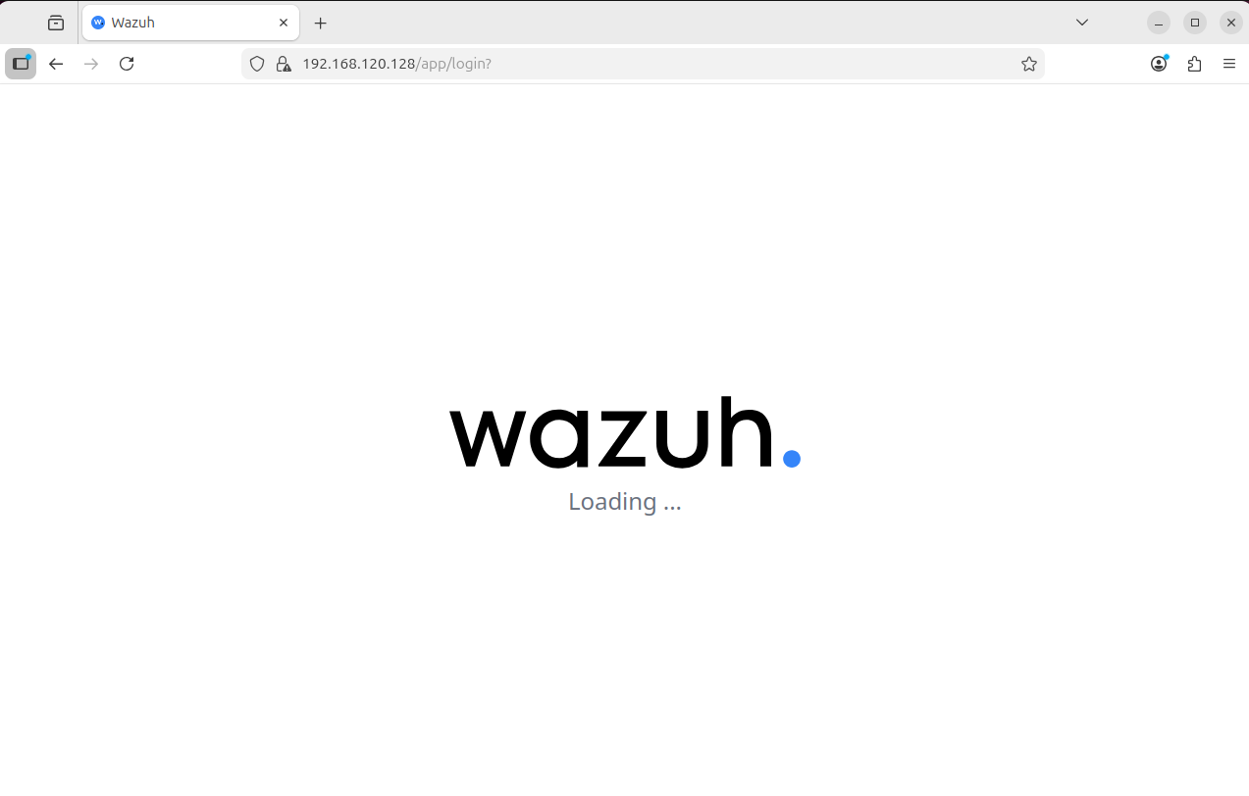

WAZUH AGENT SETUP ON WINDOWS 11

Go to Wazuh agent installer page and select the OS you want to install the Wazuh agent in. In my case it was Windows So I downloaded the Windows Installer
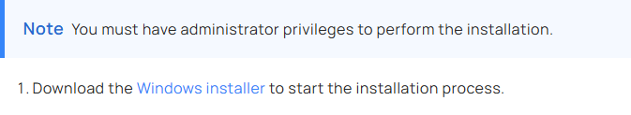

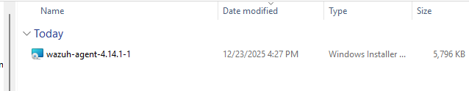

I ran above commands in Windows powershell to install the Wazuh agent and specified the IP of Ubuntu where WAZUH server, indexer and dashboard is located.
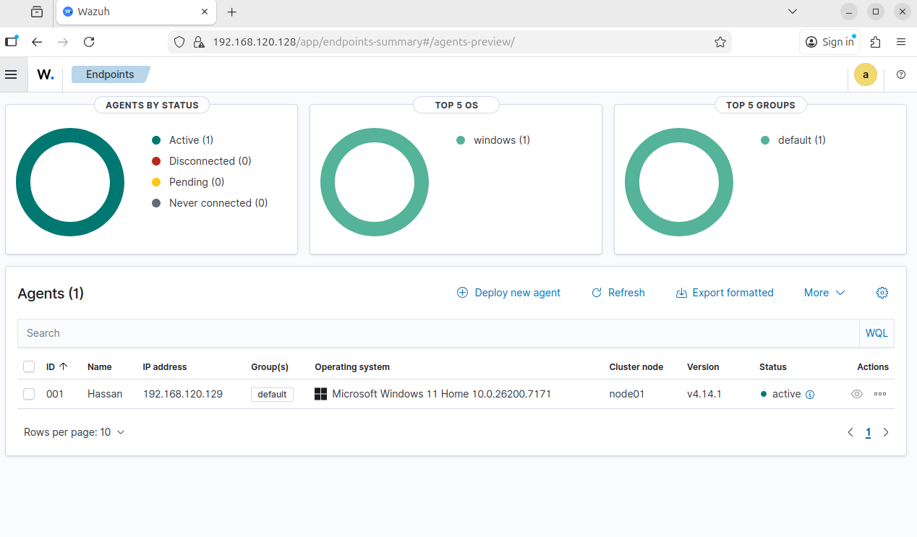
As you can see above, windows 11 is added as agent and now I can monitor it from the Wazuh Dashboard.

Attack on authentication Lab
I logged out of windows 11 and typed wrong password many times and got locked to see if its log is generated in Wazuh Dashboard.


As you can see, the logs are generated for entering wrong password.

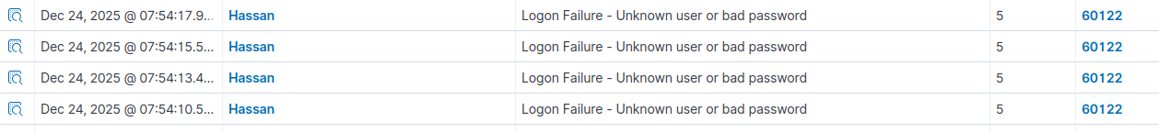

CREATING NEW USER
I created new user on windows 11 and checked if it’s log is generated.
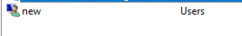

Attack on File Integrity Lab
To Do file integrity lab, I created a dummy file in the C drive just for the sake of testing.
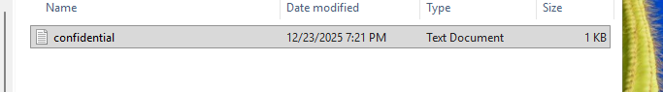
To monitor this file, I added <directories whodata="yes" check_all="yes" report_changes="yes">C:\<DIRECTORY NAME></directories> in WAZUH AGENT under syscheck section to command WAZUH SIEM TO MONITOR THIS FOLDER AND ITS CONTENTS IN REAL TIME. IN WAZUH AGENT GUI APP. Navigate to view then view config to add this under syscheck section for monitoring this file.

Then to test it I modified the contents of the file

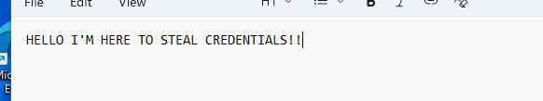

File integrity alert is generated.
